EDRC Use Case 1, Test Case 1, Section 6.1.3 Revision Number
Revision:

11 | Updated to reflect comments from David Price | K Willshaw  30 March 2015

Test case spec release 1.0

6.1.3 Revision Number

This was identified in the IIP process as ‘Code to identify and track the revisions for a document’ and is a property of the document not the Pump so we need to establish an idenity for the Document and set a relationship between Document and Pump.

This is done using the following Templates:

Define Document (ClassificationOfClassOfIndividual)

NOTE – Although we are using Templates for Individuals in the case of a Document such as the DataSheet or a P&ID we are actually dealing with a Class. This may seem odd as we are talking about the datasheet for a specific pump. However if we consider this further the datasheet is NOT an individual as many copies of it may exist on different devices and on paper. So unless we are talking about a uniquely identified or a specific master computer file we must regard documents as classes.

Comment – this instance is reused by import of Job Number test case.

Role  No | Role Name | Role Type | Example
1 | hasClassified | ClassOfIndividual | Uuid of Data Sheet
2 | hasClassifier | ClassOfClassOfIndividual | API DATA SHEET CLASS

Define Identification (ClassifiedIdentificationOfClassOfIndividual)

As with the Classification Template when it comes to documents we are in fact dealing with a class not an individual.

Comment - the hyperlink for the RD item is wrong.

Role  No | Role Name | Role Type | Example
1 | hasIdentified | ClassOfIndividual | ID of Datasheet declared above
2 | valIdentifier | Express String | String used to identify the document e.g.  DS-1234
3 | hasIndentificationType | ClassOfClassOfIdentification | DOCUMENT NAME ASSIGNMENT CLASS

Comment : valIdentifier role type is incorrect in this table, the template actually states (tpl:valIdentifier only xsd:string)

The DATA SHEET object is defined as being of entity type ClassOfInformationObject and its function is to represent the Pump so the most appropriate relationship Template is ReferenceToIndividualOnDocument which is defined as follows

Role  No | Role Name | Role Type | Example
1 | hasReferred | PossibleIndividual | Uuid of the Pump established on declaration
2 | hasDocument | ClassOfInformationObject | Uuid of the Data Sheet established on declaration

The Revision number is a key identification property for the document so was mapped as follows using the template ClassifiedIdentificationOfClassOfIndividual

Comment – RD item was missing so I added it.

Role  No | Role Name | Role Type | Example
1 | hasIdentified | ClassOfIndividual | Uuid of the Data Sheet established on declaration
2 | valIdentfier | Express String | Rev 1
3 | hasIndentificationType | ClassOfClassOfIdentification | REVISION CODE ASSIGNMENT CLASS

Comment : valIdentifier role type is incorrect in this table, the template actually states (tpl:valIdentifier only xsd:string)

In an Sparql endpoint the revised document would in fact have a different identifier to the original document (e.g. Identifier xxxxx rev.y where xxxxx is the identifier of the whole life document and y is the revision of the document. Thus in our case revision 9 of DS-1234 would the complete identifier DS-1234.rev9 and no separate revision identifier is needed or desirable. However as the API Datasheet requires a revision field and we are using a simple data transfer protocol it has been included.

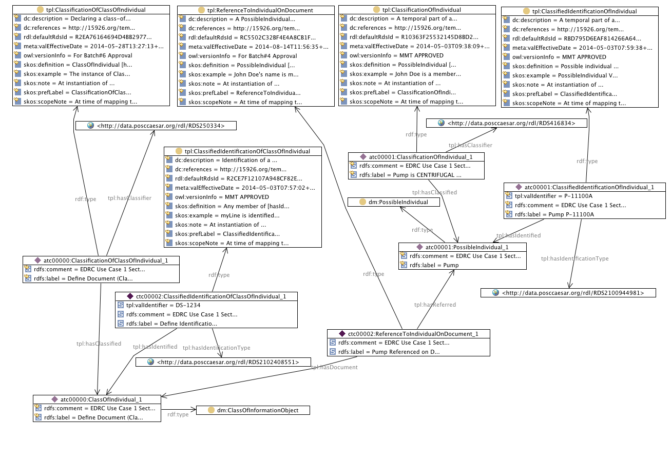

SPARQL to find Pump on Datasheet

SELECT ?PumpIdentifier ?DatasheetIdentifier
WHERE {
?classificationofindividual rdf:type tpl:ClassificationOfIndividual .
?classificationofindividual tpl:hasClassifier <http://data.posccaesar.org/rdl/RDS416834> .
?classificationofindividual tpl:hasClassified ?possibleindividual .
?classifiedidentificationofindividual rdf:type tpl:ClassifiedIdentificationOfIndividual .
?classifiedidentificationofindividual tpl:hasIdentificationType <http://data.posccaesar.org/rdl/RDS2100944981> .
?classifiedidentificationofindividual tpl:hasIdentified ?possibleindividual .
?classificationofclassofindividual tpl:hasClassifier <http://data.posccaesar.org/rdl/RDS345689> .
?classificationofclassofindividual tpl:hasClassified ?classofinformationobject .
?classificationofclassofindividual rdf:type tpl:ClassificationOfClassOfIndividual .
?classifiedidentificationofclassofindividual tpl:hasIdentified ?classofinformationobject .
?classifiedidentificationofclassofindividual tpl:hasIdentificationType <http://data.posccaesar.org/rdl/RDS2102408551> .
?classifiedidentificationofclassofindividual rdf:type tpl:ClassifiedIdentificationOfClassOfIndividual .
?possibleindividual rdf:type dm:PossibleIndividual .
?classofinformationobject rdf:type dm:ClassOfInformationObject .
?referencetoindividualondocument tpl:hasDocument ?classofinformationobject .
?referencetoindividualondocument rdf:type tpl:ReferenceToIndividualOnDocument .
?referencetoindividualondocument tpl:hasReferred ?possibleindividual .
?classifiedidentificationofindividual tpl:valIdentifier ?PumpIdentifier .
?classifiedidentificationofclassofindividual tpl:valIdentifier ?DatasheetIdentifier .
}
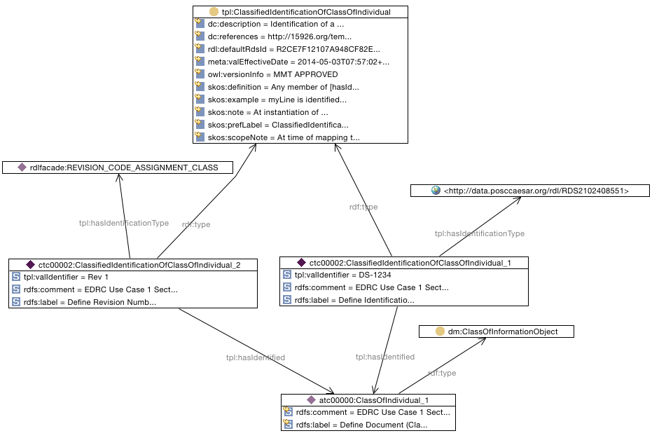

Find Id and Rev of Datasheet

SELECT ?DatasheetIdentifier ?DatasheetRevisionCode
WHERE {
?classifiedidentificationofclassofindividual1 tpl:hasIdentified atc00000:ClassOfIndividual_1 .
?classifiedidentificationofclassofindividual1 tpl:hasIdentificationType <http://data.posccaesar.org/rdl/RDS2102408551> .
?classifiedidentificationofclassofindividual1 rdf:type tpl:ClassifiedIdentificationOfClassOfIndividual .
?classifiedidentificationofclassofindividual tpl:hasIdentified atc00000:ClassOfIndividual_1 .
?classifiedidentificationofclassofindividual rdf:type tpl:ClassifiedIdentificationOfClassOfIndividual .
?classifiedidentificationofclassofindividual tpl:hasIdentificationType rdlfacade:REVISION_CODE_ASSIGNMENT_CLASS .
atc00000:ClassOfIndividual_1 rdf:type dm:ClassOfInformationObject .
?classifiedidentificationofclassofindividual1 tpl:valIdentifier ?DatasheetIdentifier .
?classifiedidentificationofclassofindividual tpl:valIdentifier ?DatasheetRevisionCode .
}

